Task 2
Title:
Multiple Sequence Alignment (MSA)
By: Anshara Maheen

1. Sequence Source (NCBI)
The following protein sequences were retrieved from the National Center for Biotechnology Information database in FASTA format:
- XEF57200.1 (Homo sapiens – Hb Monza)
- AAA35597.1 (Homo sapiens – beta-globin)
- NP_001257812.1 (Canis lupus familiaris – beta-like)
- NP_001291812.1 (Ailuropoda melanoleuca – beta-like)
- NP_001291814.1 (Ailuropoda melanoleuca – delta globin)
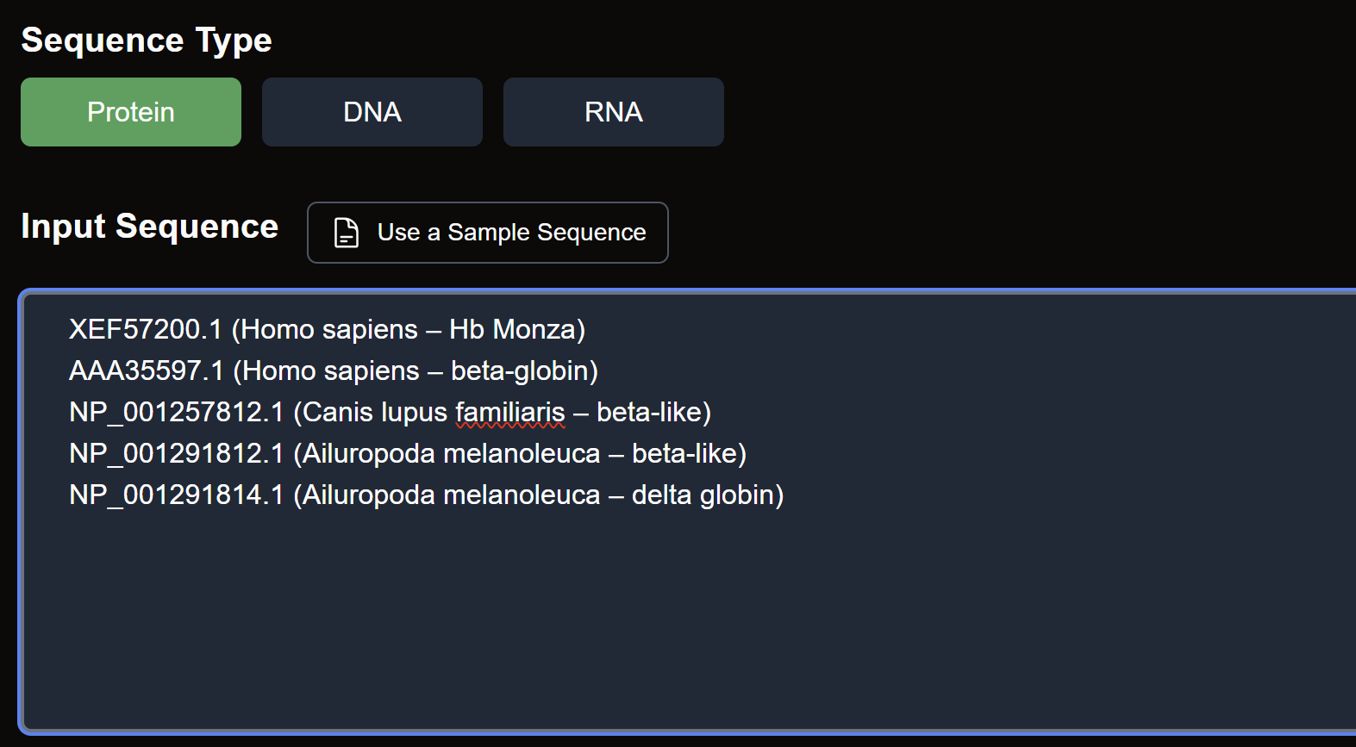
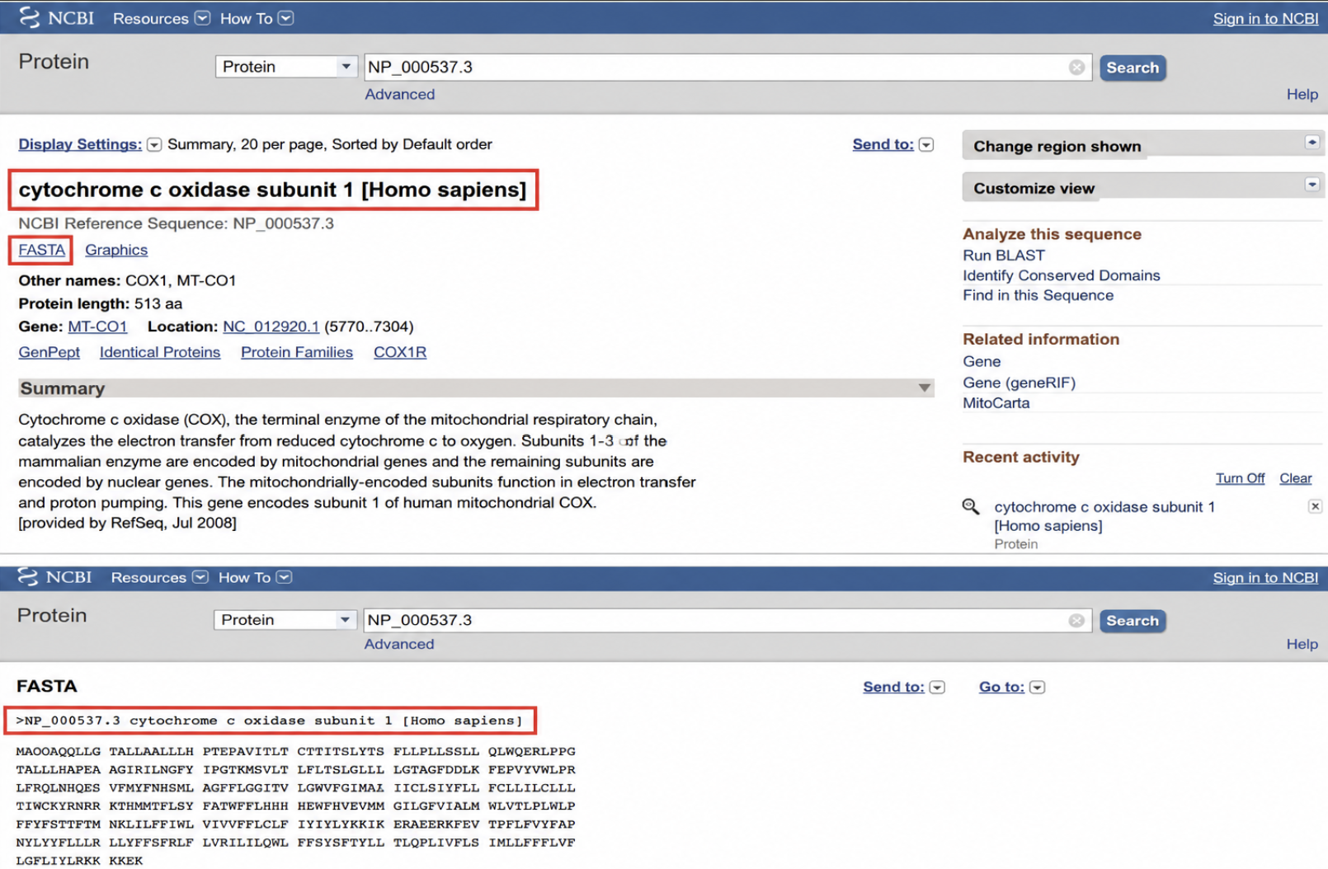
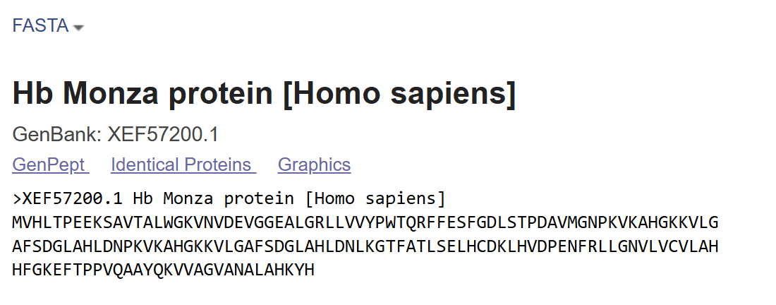
- >XEF57200.1 Hb Monza protein [Homo sapiens]
MVHLTPEEKSAVTALWGKVNVDEVGGEALGRLLVVYPWTQRFFESFGDLSTPDAVMGNPKVKAHGKKVLG
AFSDGLAHLDNPKVKAHGKKVLGAFSDGLAHLDNLKGTFATLSELHCDKLHVDPENFRLLGNVLVCVLAH
HFGKEFTPPVQAAYQKVVAGVANALAHKYH
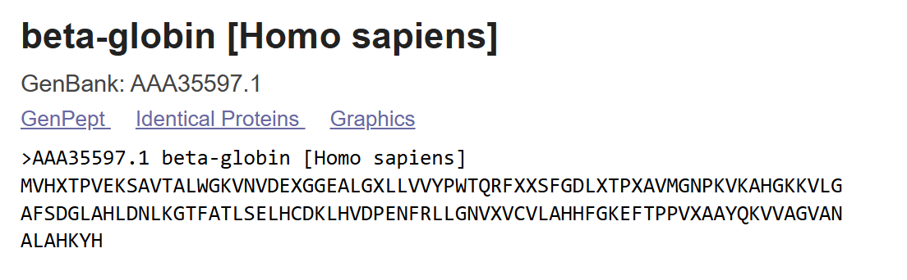
- >AAA35597.1 beta-globin [Homo sapiens]
MVHXTPVEKSAVTALWGKVNVDEXGGEALGXLLVVYPWTQRFXXSFGDLXTPXAVMGNPKVKAHGKKVLG
AFSDGLAHLDNLKGTFATLSELHCDKLHVDPENFRLLGNVXVCVLAHHFGKEFTPPVXAAYQKVVAGVAN
ALAHKYH

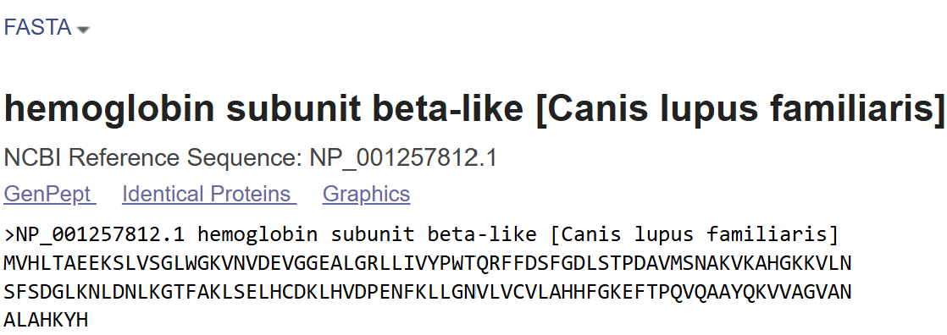
- >NP_001257812.1 haemoglobin subunit beta-like [Canis lupus familiaris]
MVHLTAEEKSLVSGLWGKVNVDEVGGEALGRLLIVYPWTQRFFDSFGDLSTPDAVMSNAKVKAHGKKVLN
SFSDGLKNLDNLKGTFAKLSELHCDKLHVDPENFKLLGNVLVCVLAHHFGKEFTPQVQAAYQKVVAGVAN
ALAHKYH
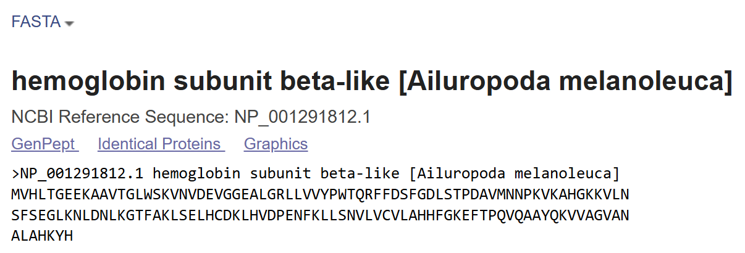
- >NP_001291812.1 hemoglobin subunit beta-like [Ailuropoda melanoleuca]
MVHLTGEEKAAVTGLWSKVNVDEVGGEALGRLLVVYPWTQRFFDSFGDLSTPDAVMNNPKVKAHGKKVLN
SFSEGLKNLDNLKGTFAKLSELHCDKLHVDPENFKLLSNVLVCVLAHHFGKEFTPQVQAAYQKVVAGVAN
ALAHKYH

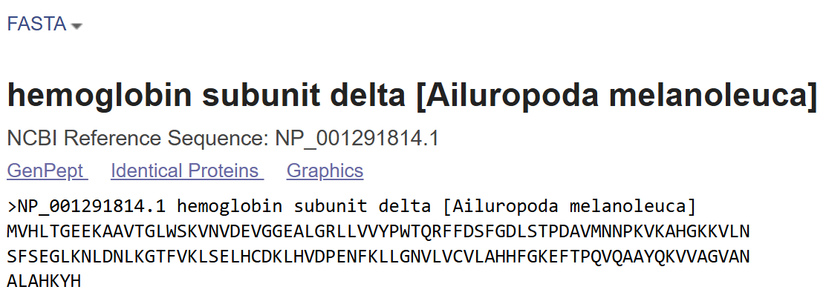
- >NP_001291814.1 hemoglobin subunit delta [Ailuropoda melanoleuca]
MVHLTGEEKAAVTGLWSKVNVDEVGGEALGRLLVVYPWTQRFFDSFGDLSTPDAVMNNPKVKAHGKKVLN
SFSEGLKNLDNLKGTFVKLSELHCDKLHVDPENFKLLGNVLVCVLAHHFGKEFTPQVQAAYQKVVAGVAN
ALAHKYH
- Tool Used
- Multiple sequence alignment was carried out using Clustal Omega.
- Clustal Omega aligns sequences based on sequence similarity and evolutionary relationships.
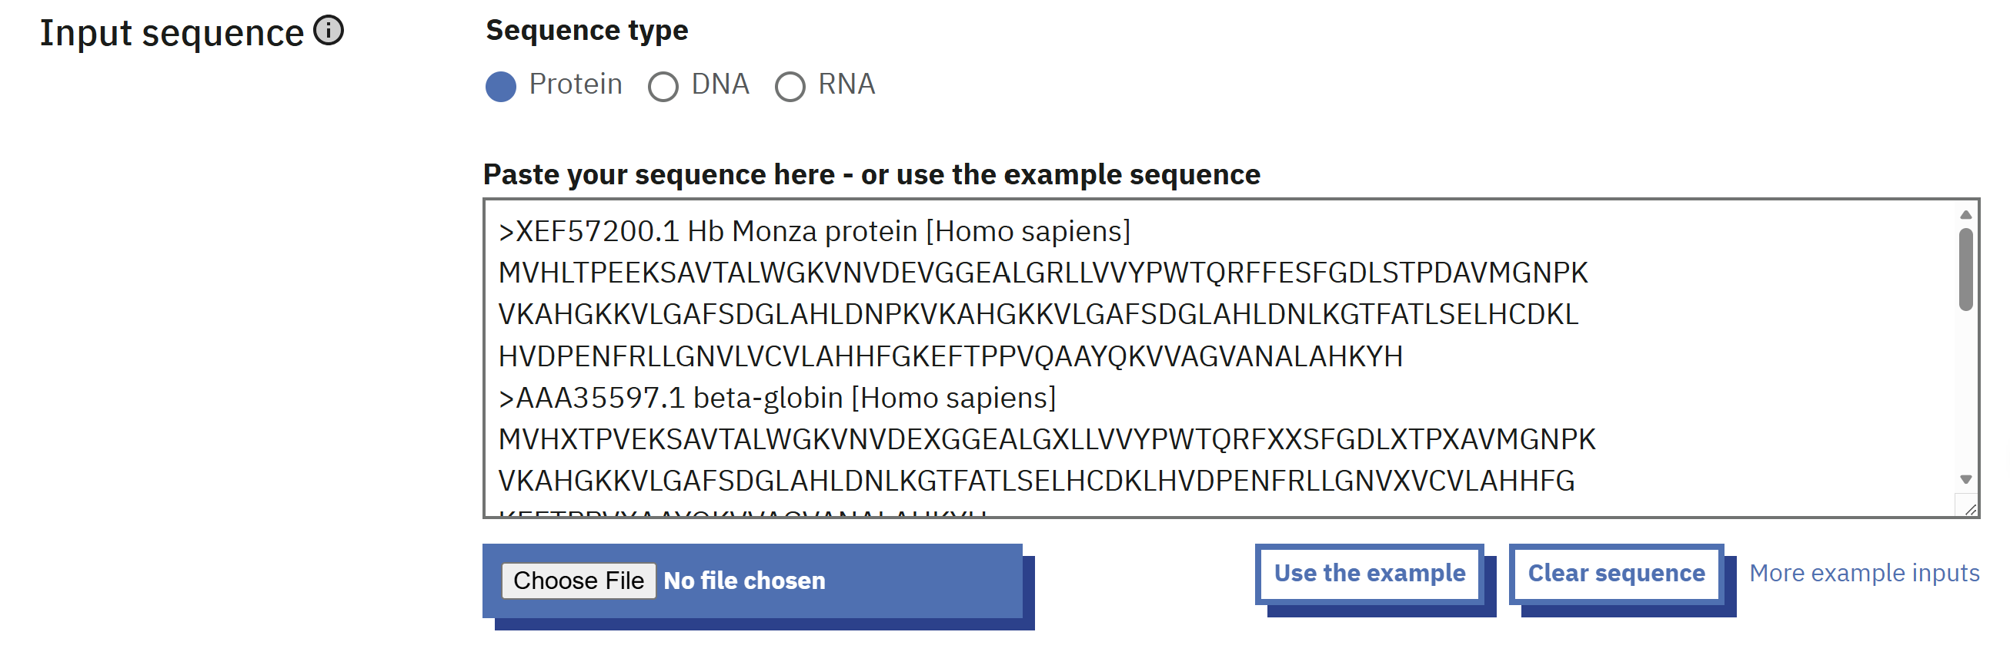
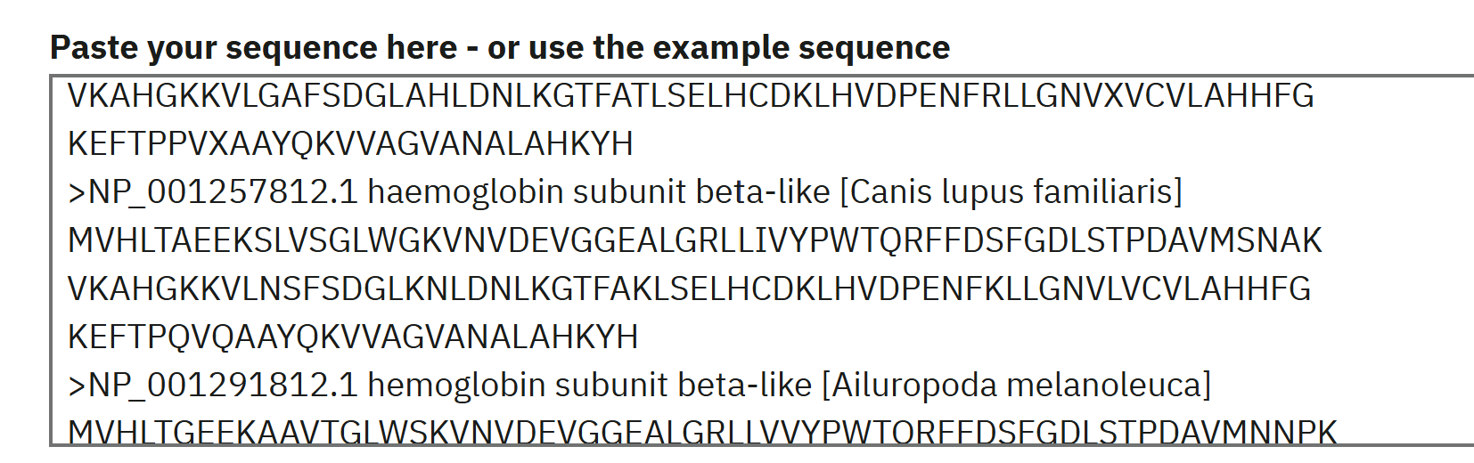
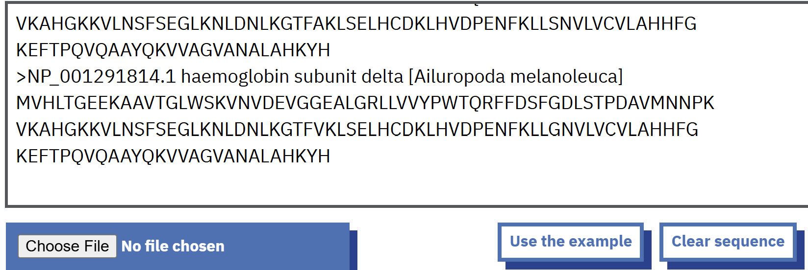

- Alignment Result
The aligned sequences showed strong similarity across all selected globin proteins. In the alignment output, the symbol (*) indicates fully conserved amino acids across all sequences, (:) indicates strongly similar amino acids with similar biochemical properties, and (.) indicates weakly similar residues. The alignment revealed minimal variations, with most amino acids conserved across species.
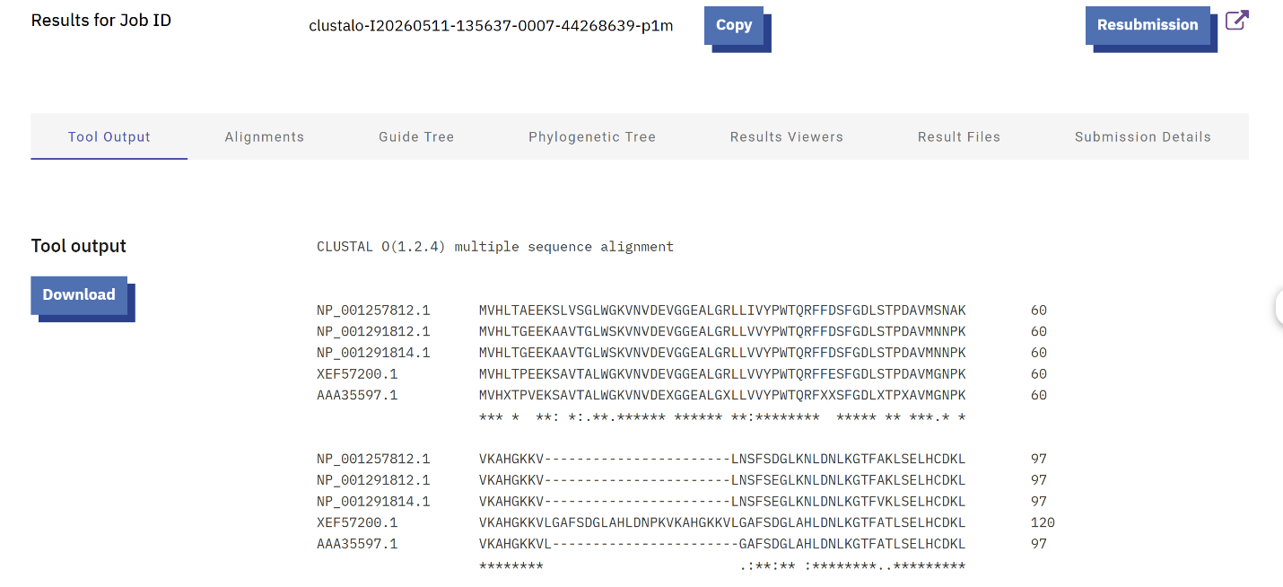
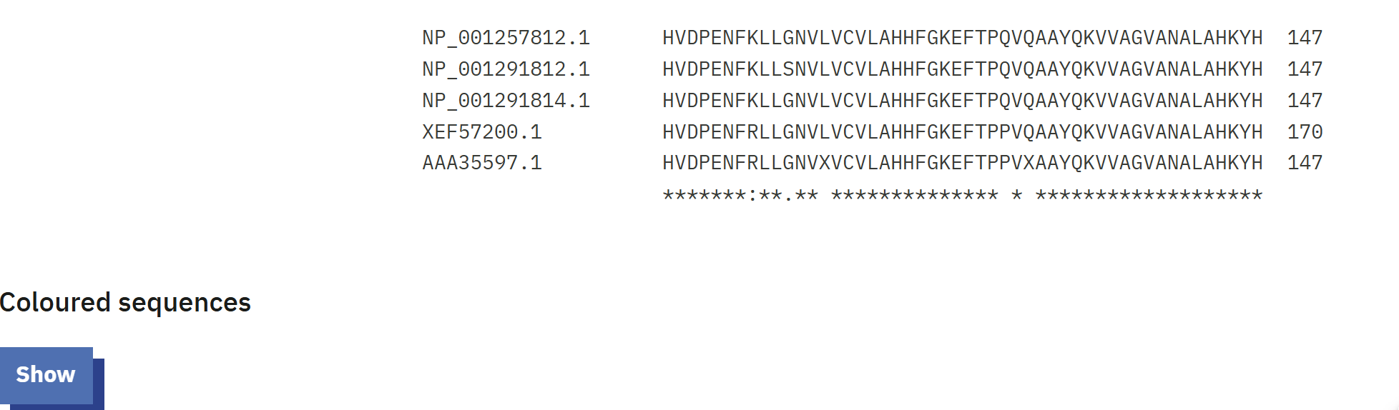
Multiple sequence alignment of globin proteins using Clustal Omega showing conserved regions (*)

- Conserved Regions and Motifs
The alignment revealed several highly conserved regions:
- WGKVNV → conserved motif involved in globin structural stability
- GGEALGRLLVVYPWTQR → highly conserved region important for oxygen-binding function
- KVKAHGKKV → conserved functional region associated with heme interaction and protein activity
These regions are conserved across all species, indicating their importance in protein function.

- Interpretation
The findings indicate that globin proteins are strongly conserved among species such as humans, dogs, and pandas. Conserved amino acid regions highlight their essential role in oxygen binding and maintaining protein stability. Although slight variations and gaps appear in some sequences, they reflect evolutionary changes without greatly impacting function. Overall, the high level of conservation supports a shared evolutionary origin of globin proteins. The high conservation among mammalian globin proteins suggests a common evolutionary ancestor and highlights the biological importance of these proteins.

Conclusion
The multiple sequence alignment effectively revealed conserved regions and motifs within the globin protein family. These conserved elements emphasize the importance of certain amino acids in preserving the protein’s structure and function. The results also show that MSA is a valuable approach for analyzing evolutionary relationships and functional conservation among proteins.

References
[1] European Bioinformatics Institute (EMBL-EBI) (n.d.) Clustal Omega Multiple Sequence Alignment Tool. Available at: https://www.ebi.ac.uk/Tools/msa/clustalo/ (Accessed: 14 May 2026).
[2] National Center for Biotechnology Information (NCBI) (n.d.) Protein database and sequence resources. Available at: https://www.ncbi.nlm.nih.gov/protein/ (Accessed: 14 May 2026).
[3] UniProt Consortium (n.d.) UniProt: a worldwide hub of protein sequence and functional information. Available at: https://www.uniprot.org (Accessed: 14 May 2026).
[4] Mount, D.W. (2004) Bioinformatics: Sequence and Genome Analysis. 2nd edn. Cold Spring Harbor Laboratory Press.

